



**AIM:** To demonstrate the single and double precision formats to represent floating point numbers.



# Expected OUTCOME of Experiment: (Mention CO attained here)



**Books/ Journals/ Websites referred:**

1. Carl Hamacher, Zvonko Vranesic and Safwat Zaky, “Computer Organization”, Fifth Edition, TataMcGraw-Hill.
2. William Stallings, “Computer Organization and Architecture: Designing for Performance”, Eighth Edition, Pearson.



# Pre Lab/ Prior Concepts:

The IEEE Standard for Floating-Point Arithmetic (IEEE 754) is a technical standard for floating-point computation established in 1985 by the Institute of Electrical and Electronics Engineers (IEEE). The standard addressed many problems found in the diverse floating point implementations that made them difficult to use reliably and portably. Many hardware floating point units now use the IEEE 754 standard.

The standard defines:

* *arithmetic formats:* sets of binary and decimal floating-point data, which consist of finite numbers (including signed zeros and subnormal numbers), infinities, and special "not a number" values (NaNs)
* *interchange formats:* encodings (bit strings) that may be used to exchange floating-point data in an efficient and compact form
* *rounding rules:* properties to be satisfied when rounding numbers during arithmetic and conversions
* *operations:* arithmetic and other operations (such as trigonometric functions) on arithmetic formats
* *exception handling:* indications of exceptional conditions (such as division by zero, overflow, *etc*

# Example (Single Precision- 32 bit representation )

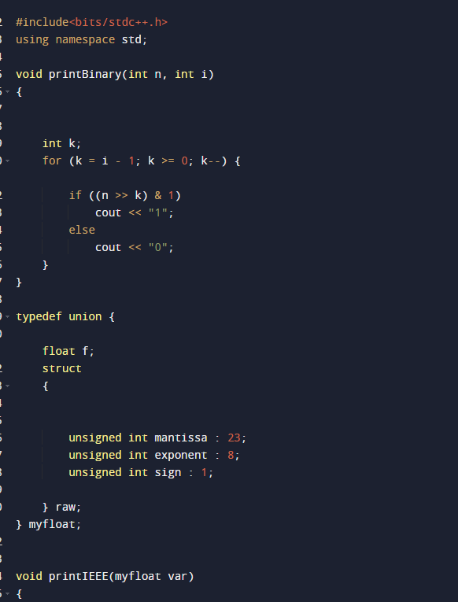

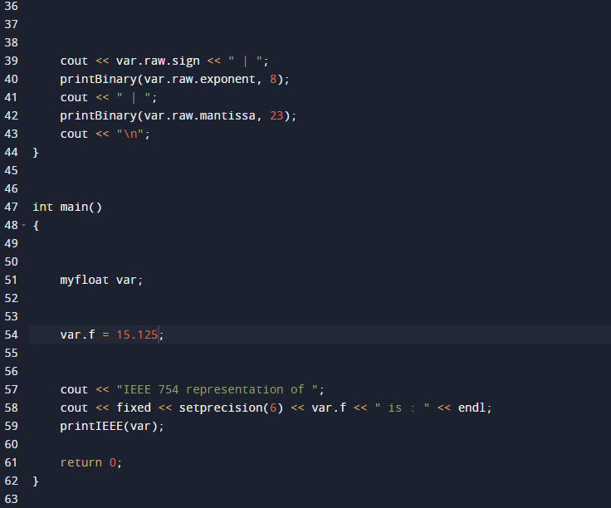

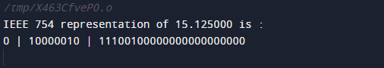

**Example (Double Precision- 64 bit representation )**

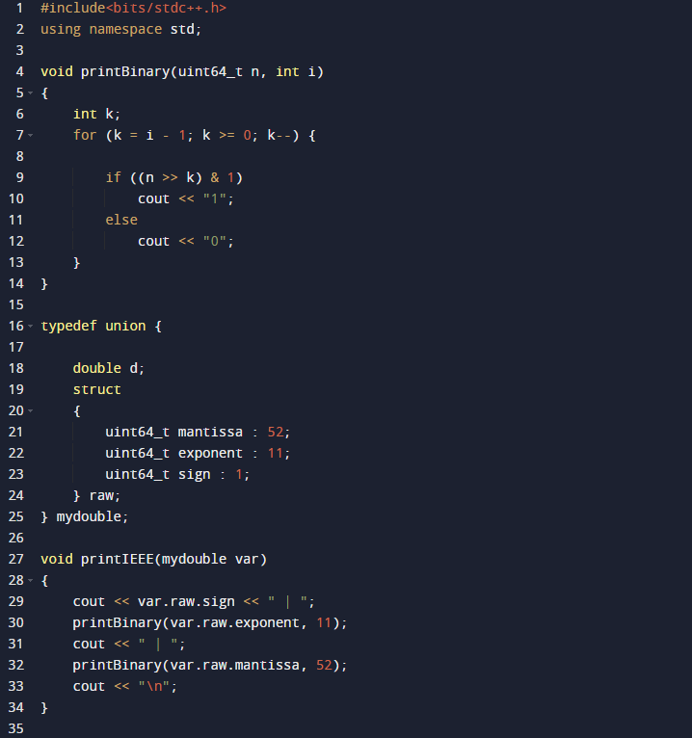

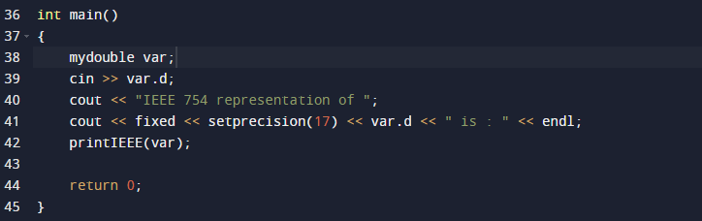

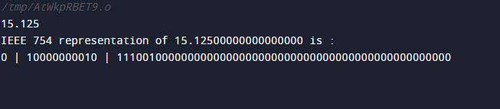

**Post Lab Descriptive Questions**

**Give the importance of IEEE-754 representation for floating point numbers?**

**ANS1)** IEEE 754 is a widely adopted standard for representing floating-point numbers in computing systems, and its importance lies in several key aspects:

1. Precision and Accuracy: IEEE 754 defines standardized formats for representing real numbers in binary form, ensuring that computations involving floating-point numbers are consistent and accurate across different hardware platforms and programming languages. This precision is essential for a wide range of scientific, engineering, and financial applications where accuracy is critical.

2. Portability: One of the primary goals of IEEE 754 is to ensure that floating-point computations produce consistent results across various computer architectures. This portability is crucial for software development because it allows programs to be written once and run on different platforms without the need for extensive code modifications or manual adjustments to handle different representations.

3. Interoperability: The IEEE 754 standard promotes interoperability between software and hardware components. It ensures that programs written on one system can be executed correctly on another system, which is particularly important in distributed computing environments and when sharing data between different software applications.

4. Well-Defined Operations: IEEE 754 specifies precise rules for arithmetic operations (addition, subtraction, multiplication, and division) on floating-point numbers. These rules help ensure that the results of mathematical computations are consistent and predictable, reducing the risk of errors in numerical algorithms.

5. NaN (Not-a-Number) and Infinity Representation: IEEE 754 provides standardized ways to represent special values like NaN and positive/negative infinity. This is valuable for handling exceptional cases in calculations and for detecting and handling errors in computations gracefully.

6. Rounding Rules: The standard defines various rounding modes (e.g., round to nearest, round toward zero, round up, and round down) that can be used when converting between different precisions or when performing arithmetic operations. These rounding rules help maintain the accuracy of computations.

7. Compatibility with Hardware: Modern computer hardware, including CPUs and GPUs, often have built-in support for IEEE 754 floating-point operations. This hardware support can significantly accelerate numerical computations, making it essential for high-performance computing and scientific simulations.

8. Widespread Adoption: The IEEE 754 standard is universally accepted in the computing industry, making it the foundation for floating-point arithmetic in most programming languages (e.g., C, Java, Python). This widespread adoption simplifies software development and interoperability. In summary, the IEEE 754 standard is vital for ensuring consistency, accuracy, and portability in floating-point arithmetic across different computer systems and programming environments. Its well-defined rules and representations play a crucial role in a wide range of applications, from scientific simulations to financial modeling and beyond.

# Conclusion

We demonstrated the single and double precision formats to represent floating point numbers.

**Date:**